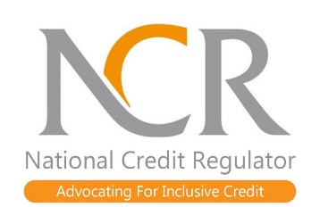
The National Credit Regulator (NCR) was established as the regulator under the National Credit Act 34 of 2005 (the Act) and is responsible for the regulation of the South African credit industry. It is tasked with carrying out education, research, policy development, registration of industry participants, i.e. credit providers, credit bureaux, alternative dispute resolution agents, payment distribution agents and debt counsellors, investigation of complaints, and enforcement of the Act. The Act requires the NCR to promote the development of an accessible credit market, particularly to address the needs of historically disadvantaged persons, low income persons, and remote, isolated or low density communities. The NCR invites applications from suitable candidates for the following position:

Position: Manager Compliance (Credit Bureau)
Paterson Grade: D - Upper
Salary Ranges from: R646 500 – R1 228 400 maximum
Ref No: CCBM/7/26

Requirements:
- The successful candidate must have a three-year commercial degree, together with relevant experience in a credit data reporting or analysis environment. A minimum of five years’ managerial experience is also required.
Duties:
- Responsible for the strategic direction and performance of the department.
- Reviewing submitted statutory reports.
- Providing inputs to regulations as and when required.
- Managing of the departmental budget in alignment with departmental operational objectives.
- Managing compliance queries from stakeholders.
- Ensuring that identified non-compliance issues are addressed and also reported to the relevant committees.
- Compiling and submitting of departmental reports (monthly, quarterly and annually).
- Managing memorandum of agreement between the NCR and SACRRA on credit reporting.
- Assess impact of regulations.
- Managing compliance reviews of bureaus.
- Developing and implementing of guidelines.

Knowledge:
- National Credit Act and other relevant legislation
- Compliance regulatory framework.
- Understanding of the South African credit market.

Skills:
- Supervisory skills
- Computer literate
- Detail orientated
- Presentation skills
- Customer focus
- Very Good communication skills – verbal and written
- Conflict management skills
- Administrative skills
- Ability to work under pressure
- Risk management
Closing Date: 16 July 2026

The National Credit Regulator is an equal opportunity organisation which offers competitive market-related packages. Suitable persons should send a detailed CV quoting the relevant reference number to: COM-Recruitment@ncr.org.za.

Correspondence will only be entered into with short listed candidates. The National Credit Regulator reserves the right not to make an appointment.
 Ref: CCBM/7/26

